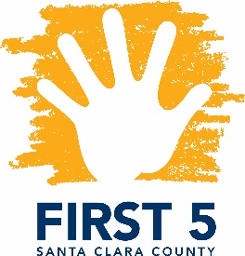
Special Topics in Special Needs
Facilitated by Parents Helping Parents & Financed by FIRST 5 Santa Clara County

Helping Young Children with Autism Thrive

Presented by Dr. Trenna Sutcliffe

Designed for FIRST 5 Partners and other Local Professionals

Tuesday, January 30, 2018
9:30 a.m. – 12:30 p.m.

In this highly interactive workshop, learn effective strategies and interventions to support young children on the Autism Spectrum. Dr. Trenna Sutcliffe will provide up-to-date information on Autism Spectrum Disorder and discuss various treatment approaches. She will also present on Applied Behavioral Analysis, calming techniques, tips for children who are starting school, and reasons for why medication may be considered.
This training is open to First 5 partners, therapeutic and related service providers, and parents! Certificates are available upon request, indicating hours earned against the Infant-Family Early Childhood Mental Health Guidelines.
Dr. Trenna Sutcliffe is a board-certified medical doctor in developmental & behavioral pediatrics in the San Francisco Bay Area, is a graduate of McMaster University School of Medicine in Hamilton, Ontario. She completed residency training in pediatrics and trained in pediatric neurology at The Hospital for Sick Children in Toronto, and completed a fellowship in developmental pediatrics at the University of Toronto. In addition, Sutcliffe earned a Master’s degree in medical genetics at the University of Toronto and a Master’s degree in clinical epidemiology at Stanford University.

Location: Parents Helping Parents
Sobrato Center for Nonprofits – San Jose
1400 Parkmoor Avenue, Suite 100
San Jose, CA 95126

Registration: Please email Judy Bower at Judy@php.com or call (408)727-5775 x 110 with any questions. To register go to PHP’s website: www.php.com

