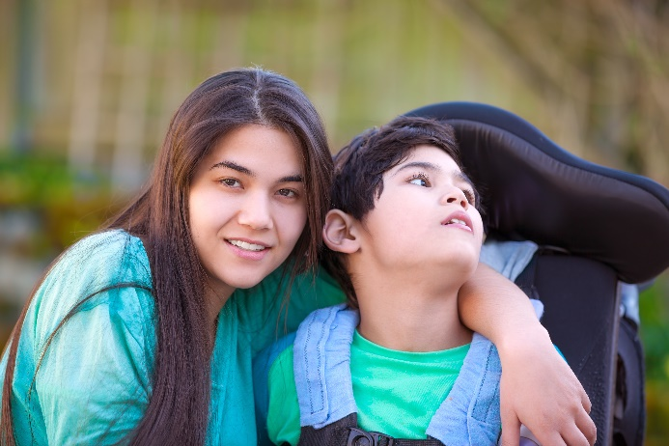

*Offered for FIRST 5 Partners and other local professionals such as Social Workers, Home Visitors, Childcare and Preschool providers, Family Resource Center staff, and Therapeutic Service Providers. Parents are also welcome.*



Facilitated by PHP

Funded by First Five Santa Clara County.

**LEARN HOW TO SUPPORT SIBLINGS**

* **Difficult feelings they might have**
* **Finding ways to develop coping skills**
* **Acceptance of differences**

We will discuss the emotional and social development of the sibling of a special needs child, early warning signs of distress, as well as evidence-based research and interventions to bolster positive outcomes for this population, which is often missed until pathology becomes apparent.

*Our presenter, Laura Beth DeHority, is a Licensed Marriage and Family Therapist (LMFT) who works with couples, siblings, groups and multi-generational families to provide support in areas of family roles and communication, stress reduction, anxiety, depression, grief and addiction. Laura Beth’s greatest area of interest is working with families who are touched by special needs, giving them the opportunity to explore solutions that will bring them hope and* *joy in their circumstances.*

January 30, 2020 | 10 AM – 12 PM

**Siblings of Young Children with Special Needs**

Registration: Search for “Siblings” at [www.php.com/calendar-of-events/](https://www.php.com/calendar-of-events/)