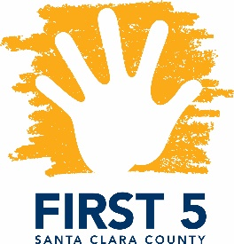
​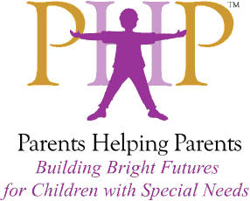Special Topics in Special Needs
Facilitated by Parents Helping Parents & Financed by FIRST 5 Santa Clara County

Siblings of Young Children with Special Needs

Presented by Laura Beth DeHority

Designed for FIRST 5 Partners and other Local Professionals

December 5, 2018
9:30 a.m. – 12:30 p.m.

Today's topic is Well Child Syndrome. We will discuss the emotional and social development of the sibling of a special needs child, early warning signs of distress as well as evidence-based research and interventions to bolster positive outcomes for this population, which is often missed until pathology becomes apparent. Spanish translation available.
Laura Beth DeHority is a Registered Marriage and Family Therapist Intern (IMF 96095, Supervisor Julie Nasser, MFC 41524) who works with couples, siblings, groups and multi-generational families to provide support in areas of family roles and communication, stress reduction, anxiety, depression, grief and addiction. Laura Beth’s greatest area of interest is working with families who are touched by special needs. Her work provides support to those who are siblings and long-term caregivers, giving them the opportunity to explore solutions that will bring them hope and joy in their circumstances. She is the Immediate Past Board Chair of Via Services, a private, independent non-profit organization dedicated to helping individuals with disabilities and special needs achieve greater self-sufficiency and lead richer lives. Laura Beth holds a M.A. in Marriage and Family Therapy and is pursuing her PsyD from California Southern University.
This training is open to First 5 partners, therapeutic and related service providers, and parents! Certificates are available upon request, indicating hours earned against the Infant-Family Early Childhood Mental Health Guidelines.

Location: Parents Helping Parents
Sobrato Center for Nonprofits – San Jose
1400 Parkmoor Avenue, Suite 100
San Jose, CA 95126

Registration: Please go to www.php.com, select PHP calendar, and search for “Siblings”

