Parents Helping Parents (PHP) Presents **Person Centered Thinking Training**

Participants will develop skills in person-centered thinking through a series of discussions, applied stories, and guided exercises. You will leave with a foundation for person centered planning.

Person Centered Thinking (PCT) is the first and fundamental training providing participants with the basic knowledge on how to facilitate the use of the skills and tools to support others. Participants will develop their own descriptions using the skills and tools. Changing your thinking is the first step to person centered planning.

|  |  |
| --- | --- |
| **2-Day Training  January 13 & 20, 2018**  **(2 Saturdays)**  **9:30 am – 4:30 pm** | **2-Day Training  March 16 & 17, 2018**  **(Fri/Sat)**  **9:30 am – 4:30 pm** |
| **One-Page Profile Workshop Saturday, March 3, 2018**  **9:30 am – 1:00 pm**  *The One Page Profile Workshop is funded by California Children’s Services*  *No fee to attendees.*  We believe that one-page profiles are the foundation of personalization, and can lead to positive change for people, whatever their age or circumstances. They provide us with an at-a-glance way of knowing what really matters to people, that can be taken with them as they move through services and come into contact with people. | |

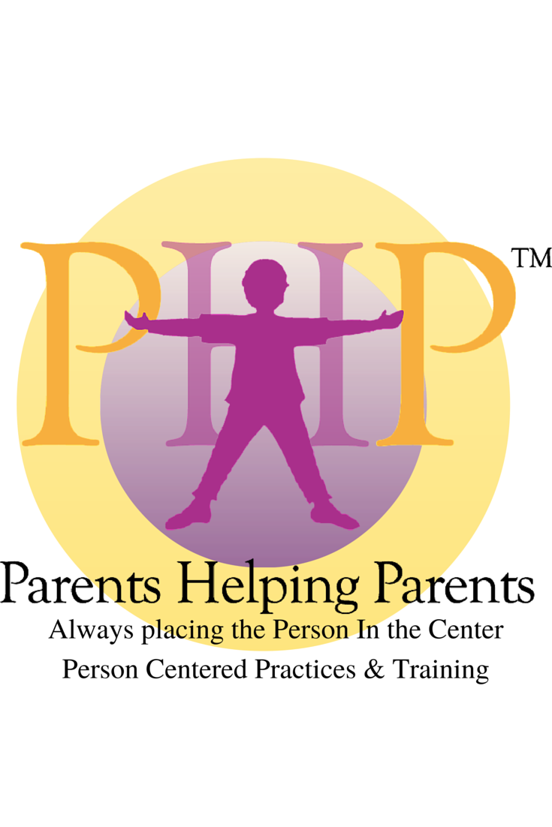

`

This training offers 12-hours of learning and practicing how to use a variety of skills to discover information to support someone to have a better life.

The skills offer specific methods to discover information that identifies ***what is important to a person and what is important for a person****.*

It is this discovery process that leads to finding the *balance between important to and for* which serves as the basis to create a description of a person that leads to action planning. The tools of discovery were developed by Michael Smull and the Learning Community to support people to get better lives…not just better plans.

**OR**

Location for all events: PHP at The Sobrato Center for Nonprofits  
1400 Parkmoor Av, San Jose CA 95126 www.php.com/directions

**Register at: http://www.php.com/person-centered-thinking-training**

**2-DAY PCT Training Member Fee | Non-Member Fee**

Professional $125 $155

Parent $ 95 $125

Team Team of 10 $1,100/ team ($110 ea)

**Questions?**

Call 408-727-5775   
info@php.com  
www.php.com



Those who successfully complete the PCT training are able to use the training to facilitate the tools, but are not certified to train others. Certification as a PCT Trainer is offered through the Learning Community. www.tlcpcp.com

Those who successfully complete the PCT training are able to use the training to facilitate the tools, but are not certified to train others. Certification as a PCT Trainer is offered through the Learning Community.