How ​ to​ ​ Create​ ​ a​
Community ​ of​
Learning ​ Account​
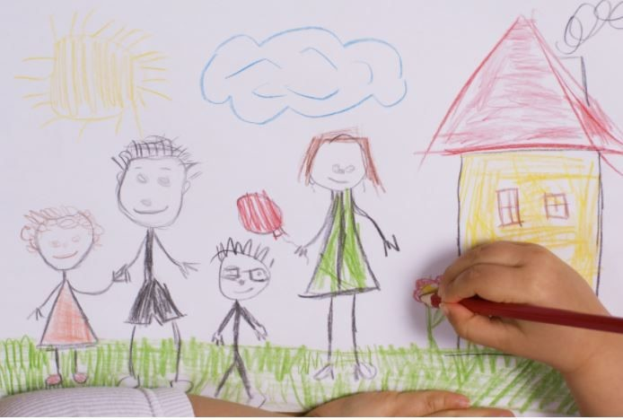
FIRST ​ 5​ 's ​ Community​ ​ of​ ​ Learning​​ (​ COL) ​ is​ a​ cross-system​ ​ ​and​ ​multidisciplinary workforce ​ development​ ​ ​institute​ ​that provides​ ​child-focused ​ and​ family-centered​ professional​ ​ ​development
opportunities​ ​for​ ​FIRST​ ​5​ ​partners​ ​and community ​ members.​
You​ ​will​ ​need​ ​to​ ​create​ ​your​ ​Community of​ ​Learning​ ​profile​ ​prior​ ​to​ ​registering​ ​for a​ ​workshop.

Step​ ​1: ​ Create​ ​ a​ ​ Community​ ​ of​ ​ Learning​ profile​ ​by​ ​logging​ ​on​ ​to​ ​going​ ​to
https://communityoflearning.first5kids.org/
or​ ​by​ ​clicking​ here​.
Step ​ 2:​ ​ ​ Wait​ ​ for​ ​ your​ ​ account​ ​ ​to ​ be​ approved​ (may​ ​take​ ​up​ ​to​ ​2​ ​business​ ​days)
Step​ ​3:​ ​ ​Log​ ​in​ ​with​ ​temporary​ ​password
Step​ ​4:​ ​Create​ ​a​ ​new​ ​password
Step​ ​5:​ ​ ​Register​ ​for​ ​workshops
For​ ​technical​ ​assistance,​ ​please​ ​email​ ​our support​ ​team​ ​at​ COL@first5kids.org​.

