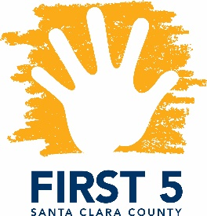
​Special Topics in Special Needs
Facilitated by Parents Helping Parents & Financed by FIRST 5 Santa Clara County

Inclusion in the Community
for Young Children with Special Needs

Presented by Susan Larkin, Inclusion Collaborative

Designed for FIRST 5 Partners and other Local Professionals

October 3, 2018
9:30 a.m. – 12:30 p.m.

This workshop examines how child care providers, preschool teachers, and community workers can support children with special needs in their programs. We will look at Inclusion Collaborative services, who needs support, how to treat people who have disabilities, why we should include all people, and what types of supports can help make inclusion work smoothly. We will look at visual support, making adaptations to the schedule, and how to adapt toys. We will look at some hands-on examples and explain how to use the Warm Line to get some ready-made supports.
Since 2008, Susan Larkin has staffed the Inclusion Collaborative Warm Line, a call/email service that supports parents, teachers and the community in inclusion and in finding disability resources. Through the Inclusion Collaborative, Susan has also taught classes on disability awareness, adaptations, behavior, calm down strategies, sensory supports, social stories, inclusive science and math, and parenting. She has created over 100 social stories and visual supports for children and teens.
This training is open to First 5 partners, therapeutic and related service providers, and parents! Certificates are available upon request, indicating hours earned against the Infant-Family Early Childhood Mental Health Guidelines.

Location: Parents Helping Parents
Sobrato Center for Nonprofits – San Jose
1400 Parkmoor Avenue, Suite 100
San Jose, CA 95126

Registration: Please go to www.php.com, select PHP calendar, and search for “Inclusion”

