WORKSHOP
Abriendo Puertas/
Opening Doors Refresher

Registration
To register, please email Laura Buzo at laura@first5kids.org. Please provide your​ name, agency, and position.

Target Audience
This is only for FRC staff that have already participated in a formal training conducted by Families in Schools in the past 3 years.

Dates and Times
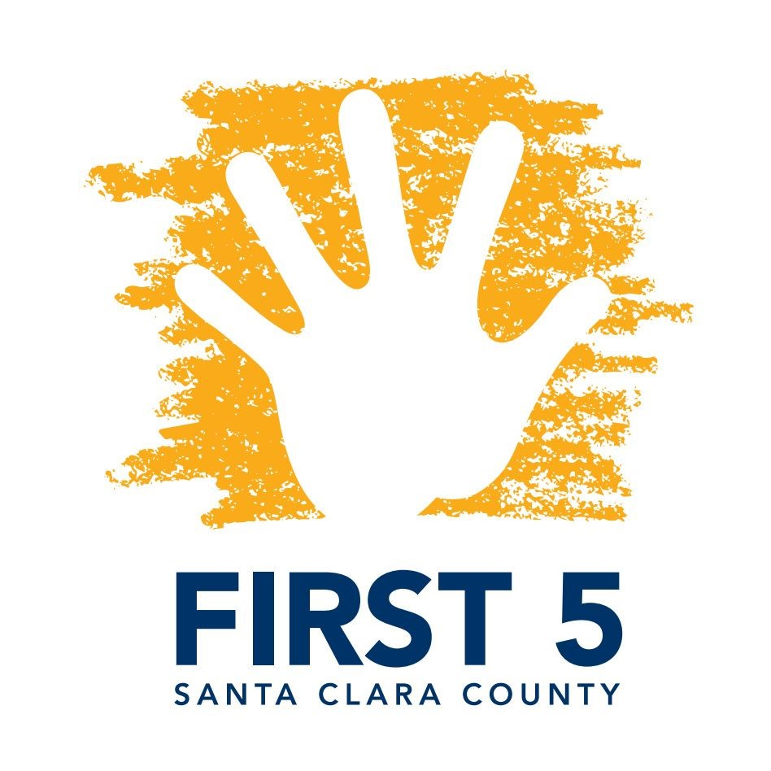
Monday - Wednesday
April 5, 2018
9:00 a.m. - 4:00 p.m.
Registration begins at 8:30 a.m.

Location
FIRST 5 Santa Clara County
4000 Moorpark Ave.
Community Room, Suite 100
San Jose, CA 95117

Description
Through the three-day training, participants will learn about the unique features of the Abriendo Puertas/Opening Doors curriculum, including:
- Overview of the 10 sessions, which cover the important aspects of child and family well-being: good health, social and emotional well-being, school readiness, and the economic well-being of the family.
- An understanding of the cultural and linguistic relevance of the Abriendo Puertas curriculum, including its use of "dichos" or popular sayings, activities such as the Lotería game and how to create a safe environment for parent reflection.

- Popular education techniques and ideas for parent outreach, and ways to engage local partners.

FIRST 5 Santa Clara County ⠂4000 Moorpark Avenue, Suite 200 ⠂San Jose, CA 95117 ⠂www.first5kids.org

