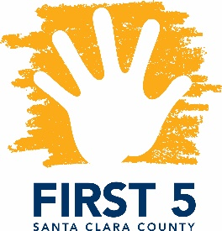
​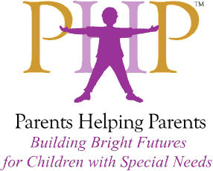Special Topics in Special Needs
Facilitated by Parents Helping Parents & Financed by FIRST 5 Santa Clara County

Resiliency after Young Childhood Trauma

Presented by Martha Johanson, LCCC

Designed for FIRST 5 Partners and other Local Professionals

September 5, 2018
9:30 a.m. – 12:00 p.m.

Martha Johansen, LCCC will lead us in a workshop on the effects of trauma on young children and the family system. This workshop is designed for parents who would like to learn more about the stress factors that affect their relationships how to manage them. Additionally, it is open to First 5 partners, therapeutic and related service providers who would like to gain a better understanding of how to best support families with young children who have experienced trauma. They will focus on:
- The ways in which trauma affects the brain
- The risk factors for trauma
- The impact of trauma on one’s overall health
- How stress affects the family system
- How to identify and manage stress levels
This training is open to First 5 partners, therapeutic and related service providers, and parents! Certificates are available upon request, indicating hours earned against the Infant-Family Early Childhood Mental Health Guidelines.

Location: Parents Helping Parents
Sobrato Center for Nonprofits – San Jose
1400 Parkmoor Avenue, Suite 100
San Jose, CA 95126

Registration: Please go to www.php.com, select PHPcalendar, and search for “Resiliency”.

