View this email in your browser
Celebrating our 40th Child Abuse Symposium
Registration will be available March 24, 2023
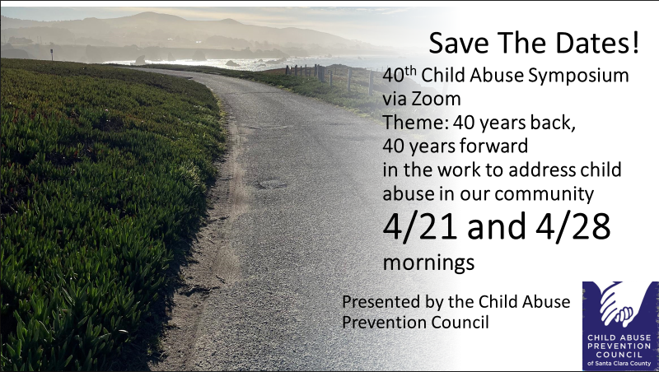
Please save the dates for the mornings of April 21 and April 28 for the Child Abuse Prevention Council’s 40th Symposium. In recognition of our 40th Symposium, our theme is “40 years back, 40 years forward”, as speakers will look back at where we’ve been and imagine where we could go in child abuse prevention, social services, medical interventions, and law enforcement.
This year, like the last two years, the Symposium will be FREE and via Zoom. Continuing education credits will be provided!
INFORMATION REGARDING PROFESSIONAL MCLE CREDIT AND CONTINUING EDUCATION CREDIT WILL BE INCLUDED WITH YOUR REGISTRATION CONFIRMATION AND EVENT REMINDER EMAIL MESSAGES
Copyright (C) 2023 Child Abuse Prevention Council of Santa Clara County. All rights reserved.
You are receiving this email because you attended or expressed interest in a Child Abuse Prevention Council event.
Child Abuse Prevention Council of Santa Clara County
70 West Hedding, 10th Floor
San Jose, CA 95110
Add us to your address book
Update Preferences | Unsubscribe

