**2018 Juvenile Justice Beyond the Bench Conference**

**Innovative Juvenile Justice**

Putting Passion into Action

[www.bytb2018.eventbrite.com](http://www.bytb2018.eventbrite.com)

Due to circumstances beyond our control Erwin Chemerinsky will no longer be able to speak at our conference. While we are disappointed at this change of events…

**We are thrilled to bring to you our new Keynote Speaker Adam Foss!!**

**[](https://www.ted.com/talks/adam_foss_a_prosecutor_s_vision_for_a_better_justice_system)        **

[Please take a few minutes and watch his thoughtful, compelling, and enlightening TED Talk held in February of 2016.](https://www.ted.com/talks/adam_foss_a_prosecutor_s_vision_for_a_better_justice_system)

Adam J. Foss is a former Assistant District Attorney in the Suffolk County District Attorney’s Office (SCDAO) in Boston, MA. Adam is a fierce advocate for criminal justice reform and the importance of the role of the prosecutor in ending Mass Incarceration. Mr. Foss believes that the profession of prosecution is ripe for reinvention requiring better incentives and more measurable metrics for success beyond, simply, “cases won.” He is the founder and president of [Prosecutor Impact](https://prosecutorimpact.com/), a not-for-profit organization built around the mission of improving community safety in the United States through a better understanding of the most important actor in the criminal justice system: the criminal prosecutor. His belief is that through education, training, and improved access to technology for the American prosecutor, we can improve results in our communities.

Due to this exciting change to the program we are extending the early bird pricing for two weeks to allow you the opportunity to register.

**Tickets**

General Admission

**(Early Bird Pricing EXTENDED to March 5th 2018)**

$100.00

MCLE Credit Admission

$150.00

**Date**

Friday, May 18, 2018

**Time**

8:00 AM – 4:00 PM

**Location**

The Westin San Jose

302 South Market Street

San Jose CA 95113

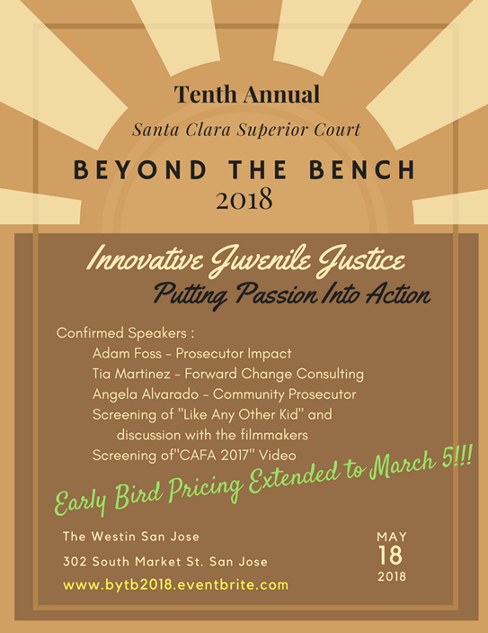

## Additional Speakers:

### Tia Martinez - Forward Change Consulting

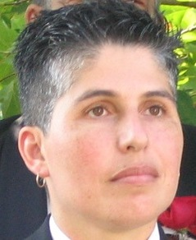

Tia Elena Martinez has over 25 years’ experience doing social change work in low income communities in the United States.  Over the decades her work has spanned a wide range of issues including education reform, the HIV/AIDS epidemic, the war on drugs, homelessness, affordable housing, disconnected youth, and immigration.  She is currently an independent consultant doing work on dismantling the school to prison pipeline and transforming life chance for boys and men of color.

Prior to consulting, she was the Chief Equity Officer at the Stupski Foundation where she designed a R and D effort focused on applying knowledge from the psychology and neuroscience to help low income students and student of color own and drive their learning and increase academic achievement.

Tia came to the foundation from the Warren Institute on Race, Ethnicity and Diversity at UC Berkeley Law School, where she was acting director of education, leading a policy unit focused on issues related to education reform, teacher effectiveness, and racial justice. Prior to joining the Warren Institute, she served as strategic consultant to the Office for Civil Rights in the US Department of Education leading their strategic planning process and supporting rollout and implementation of the new strategy across 12 regional offices.

Prior to working with the department, Tia was a senior manager with the Bridgespan Group where she led engagements with large, national foundations and major civil rights groups.  She’s also been a senior fellow at the Hewlett Foundation, a policy analyst for the Corporation for Supportive Housing and the San Francisco Mayor's HIV Health Services Planning Council, and a street outreach worker.

Tia has an AB in History from Harvard University, a Master in Public Policy from the University of California, Berkeley Goldman School of Public Policy, and a JD from Stanford Law School.

### Angela Alvarado - Community Prosecutor, Santa Clara County Office of the District Attorney

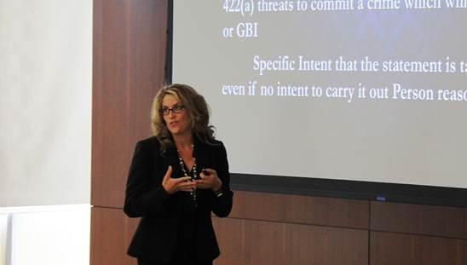

Graduated summa cum laude from Cal Poly in San Luis Obispo and UC Hastings College of the Law. She has been a deputy district attorney in Santa Clara County for 17 years. Over the last 17 years as a trial prosecutor, she has handled a variety of violent criminal cases including sexual assault, crimes against children, and juvenile crimes. For the last 10 years, she has been a state-wide instructor for law enforcement on the topics of sexual assault and child abuse and developed an Internet Safety program for Santa Clara County which combines educational training for parents, educators and students. Working in partnership with school administrators and law enforcement, she has developed curriculum to assist in the rehabilitation of minors who misuse the Internet.

## Events:

### Screening of "Like Any Other Kid" and Q & A with creator Kathy Leichtor

Kathy Leichter is an award-winning documentary film producer and director and the founder of **Two Suns Media** and [Mint Leaf Productions](http://mintleafproductions.com/), both based in New York City. Her passion and purpose is to use story to move audiences emotionally and inspire change. Leichter is the director and producer of [HERE ONE DAY](http://www.hereoneday.com/), a film about mental illness, suicide, and family which traveled to film festivals across the globe and is now being used in a nationwide screening initiative to reduce stigma, provide support, and teach about how mental illness and suicide impact families. Leichter recently produced [HIDDEN BATTLES](http://hiddenbattles.com/), a documentary about the psychological impact of killing on soldiers from across the globe. Leichter also produced and directed [PASSING ON](http://twosunsmedia.com/PassingOn.html), about her ninety-one year old, tell-it-like-it-is grandmother, Elsa, an Austrian Jewish immigrant and family therapist and the award-winning PBS documentary, [A DAY’S WORK, A DAY’S PAY](http://mintleafproductions.com/adw.html) about three welfare recipients who become leaders in the fight against workfare in New York City. Leichter was the Project Director of [THE WORKFARE MEDIA INITIATIVE](http://mintleafproductions.com/wmi.html), a media activism project which trained current and former welfare recipients to show the film [A DAY’S WORK, A DAY’S PAY](http://mintleafproductions.com/adw.html) and lead facilitated discussions educating audiences about economic justice and community organizing. Other credits include co-producer of the award-winning films, [SPIT IT OUT](http://www.mintleafproductions.com/sio.html), about a man who stutters and his journey towards self-acceptance and producer of [MOTHERS AND DAUGHTERS: MIRRORS THAT BIND](http://www.vsmproductions.com/our-films/), about the impact of the mother/daughter relationship on a woman’s body, sexuality, and self-esteem. Formerly Leichter worked at WQED-PBS, where she associate produced a national series on health care reform and worked for [MISTER ROGERS NEIGHBORHOOD](http://pbskids.org/rogers/).

### Screening of "CAFA 2017" introduction by Cassidy Higgins and Julie Tondreau

Julie Tondreau graduated from the University of San Diego with a BA in Media and Communication. She has worked in film, documentary, and advertising for the past decade.  She has lived in Vancouver, Los Angeles, and  New York City while working on a wide variety of diverse projects and is currently based in San Francisco.  She is honored to have had the opportunity to work with FLY on their recruitment video for the CAFA program, as both of her parents are judges who have been leaders in the CAFA program and is a cause very close to her family's heart.

**Benjamin T. Rada**

Santa Clara County Superior Court

Work: 408-882-2709

Cell:   408-334-9236

[brada@scscourt.org](mailto:brada@scscourt.org)