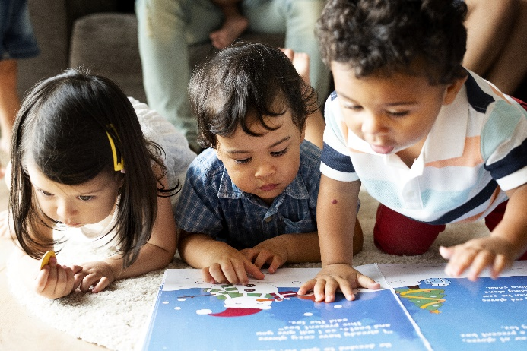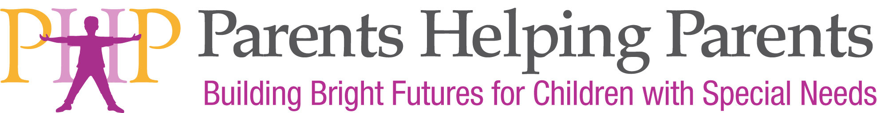

We will discuss an easy way to support inclusion in the home, the community and at school. An evidence-based practice, the goal of a Social Story is to share accurate information meaningfully and safely, promoting true social understanding. Social Stories can also be used to support friendship skills and prevent bullying.

**LEARN HOW TO WRITE SOCIAL STORIES**

* **Simply explaining situations in the community, school or at home**
* **Enabling ways for inclusion**
* **Providing social emotional support**

*Presented by Susan Larkin. Since 2008, she has staffed the Inclusion Collaborative Warm Line, a call/email service that supports parents, teachers and the community in inclusion and in finding disability resources. Through the Inclusion Collaborative, Susan has also taught classes on disability awareness, adaptations, behavior, calm down strategies, sensory supports, social stories, inclusive science and math, and parenting. She has created over 100 social stories and visual supports for children and teens.*

*Offered for FIRST 5 Partners and other local professionals such as Social Workers, Home Visitors, Childcare and Preschool providers, Family Resource Center staff, and Therapeutic Service Providers. Parents are also welcome.*



Facilitated by PHP

Funded by First Five Santa Clara County.

February 27, 2020 | 10 AM – 12 PM

**Social Stories to Support All Children**

Registration: Search for “Social Stories” at [www.php.com/calendar-of-events/](https://www.php.com/calendar-of-events/)