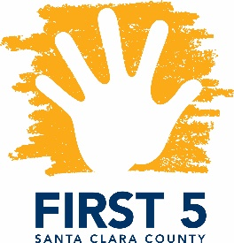
​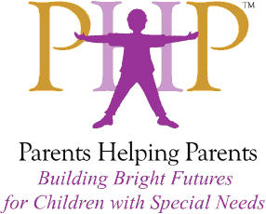Special Topics in Special Needs
Facilitated by Parents Helping Parents & Financed by FIRST 5 Santa Clara County

Overview of the Social Boundaries Program

Presented by Pramila Sindhia

Designed for FIRST 5 Partners and other Local Professionals

January 23, 2018
1:00 – 4:00 p.m.

We want our children to know how to interact appropriately with different people in their community, from family members to teachers to community helpers. The Social Boundaries Program uses the Circles™ Curriculum published by the James Stanfield Company.
This Program teaches individuals with special needs how to be safe, what is okay and not okay when interacting with others. It explores the different levels of intimacy between people, and the many ways people trust and share information in different areas of life (at home, at school, at work, in public).

Pramila Sindhia has been the Social Boundaries Instructor and Early Start Resource Specialist here at PHP since 2016. She has a Masters in Microbiology and is a mother of a 13 year old with struggles to navigate the world of social relationships. She uses the Circles curriculum to help her own child and has first-hand experience in how useful it is.
This year she is excited to take the Social Boundaries into local schools to train students and staff in their classrooms. She loves questions and a participating audience, so have fun!

This training is open to First 5 partners, therapeutic and related service providers, and parents! Certificates are available upon request, indicating hours earned against the Infant-Family Early Childhood Mental Health Guidelines.

Location: Parents Helping Parents
Sobrato Center for Nonprofits – San Jose
1400 Parkmoor Avenue, Suite 100
San Jose, CA 95126

Registration: Please go to www.php.com, select PHP calendar, and search for “Social Boundaries”

