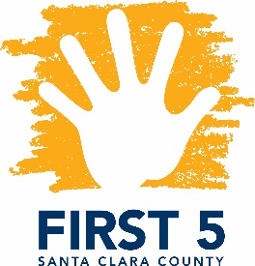
Special Topics in Special Needs
Facilitated by Parents Helping Parents & Financed by FIRST 5 Santa Clara County

Is it Just ADHD?

Understanding Dual Diagnoses in Young Children

Presented by Dr. Glen Elliott

Designed for FIRST 5 Partners and other Local Professionals

Wednesday February 7th, 2018
6:00 p.m. – 9:00 p.m.

We are delighted to have Dr. Elliott, the Chief Psychiatrist and Medical Director of the Children’s Health Council, present on ADHD in children under 5 years old. Dr. Elliott will be describing the ways in which Attention-Deficit/Hyperactivity Disorder (ADHD) may present in young children, other problems that may look like ADHD in this age group but are not, and steps parents and caregivers can take in minimizing the effects of behavioral disruptions these children often experience.

Dr. Elliott is a child and adolescent psychiatrist with a longstanding interest in normal development and in common behavioral disorders of childhood and adolescence. He has been studying and working with children who have Attention-Deficit/Hyperactivity Disorder (ADHD) since the late 1980’s. In 2006, he authored Medicating Young Minds, a book for parents facing the difficult decision of using medications for children with severe behavioral problems. Dr. Elliott was Director of The Children’s Center at Langley Porter at UCSF from 1989 until retiring in 2006 as an Emeritus Professor of Clinical Psychiatry. Since then, he has been at the Children’s Health Council (CHC) serving as Chief Psychiatrist and Medical Director. He also is a Professor of Clinical Psychiatry (Affiliated) in the Stanford School of Medicine Department of Psychiatry and Behavioral Sciences and Associate Director of Training for Stanford’s Child and Adolescent Psychiatry Program.

This training is free. Pre-registration is required. Certificates of attendance are issued for LMFTs, LCSWs indicating hours earned against the Infant-Family Early Childhood Mental Health Guidelines.

Location: Parents Helping Parents
Sobrato Center for Nonprofits – San Jose
1400 Parkmoor Avenue, Suite 100
San Jose, CA 95126

Registration: Please email Judy Bower at judy@php.com or call (408)727-5775 x110 with any questions.

