**The Building Blocks of ParentingTM Family Engagement App**

**PROFESSIONAL DEVELOPMENT WORKSHOP**



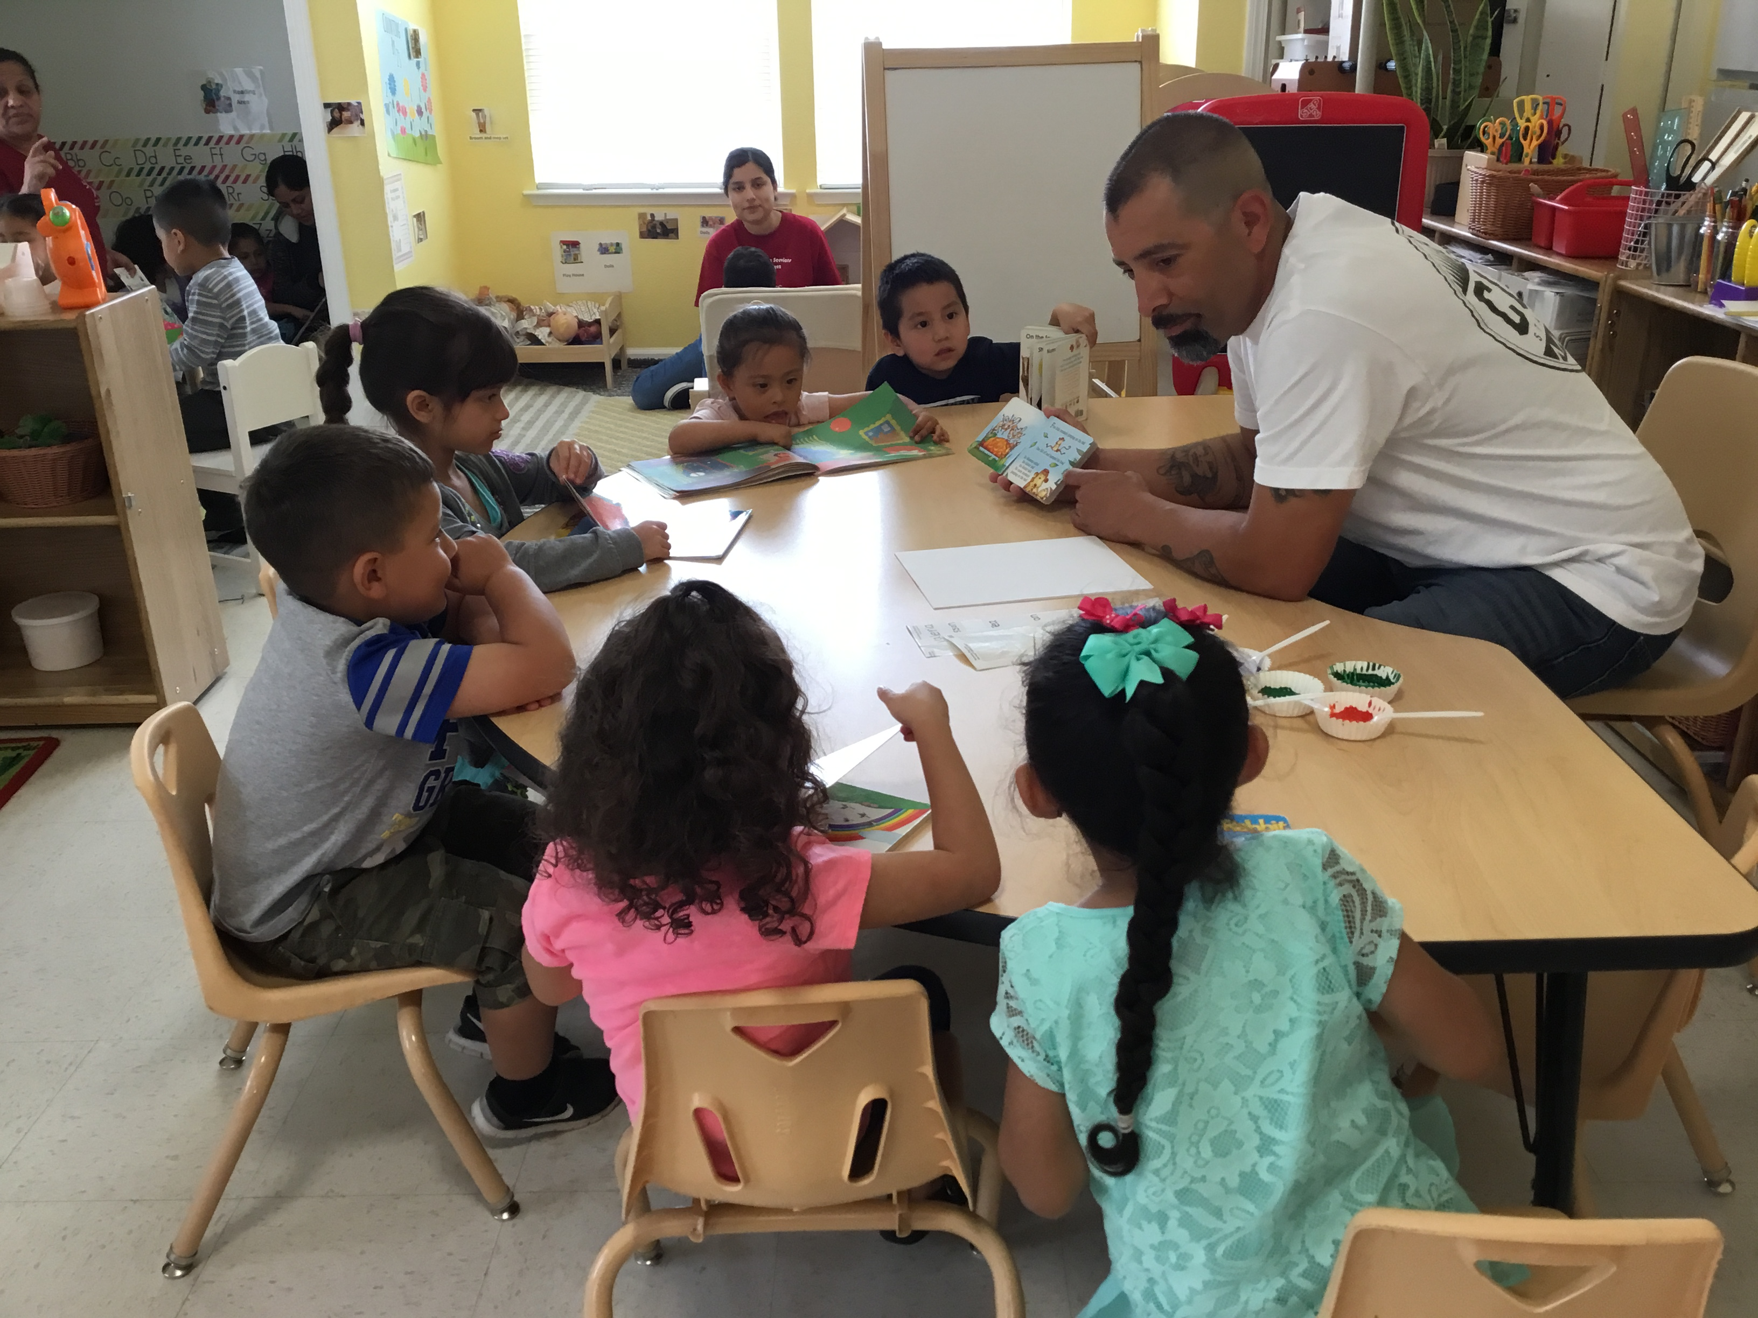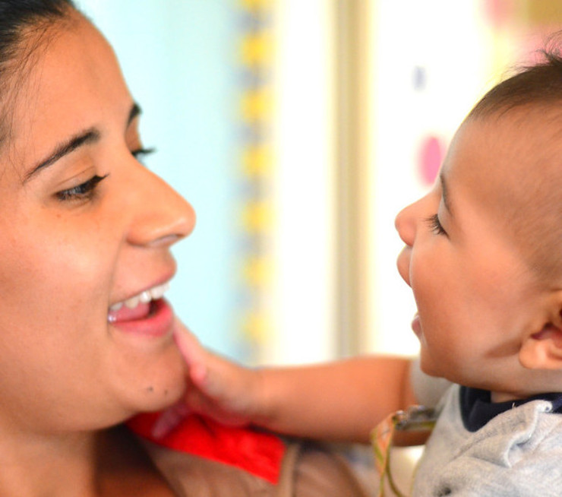

**OBJECTIVES:**

**At the end of the workshops, participants will be able to:**

# **Apply family engagement core competencies to strengthen their partnerships with families**

# **Define the Building Blocks of Parenting and apply them to their work with families**

* **Utilize the Building Blocks of Parenting App as a tool to engage families at the Family Resource Center**

Dates: 12/8/20, 12/9/20 and 12/10/20

Time: 1 pm to 2 pm

You must attend all 3 sessions

LOCATION: Virtual Zoom Meeting

Workshop Facilitators:

Nereyda Hurtado, Ph.D. and Nora Guerra, M.A., Grail Family Services



**To register:**